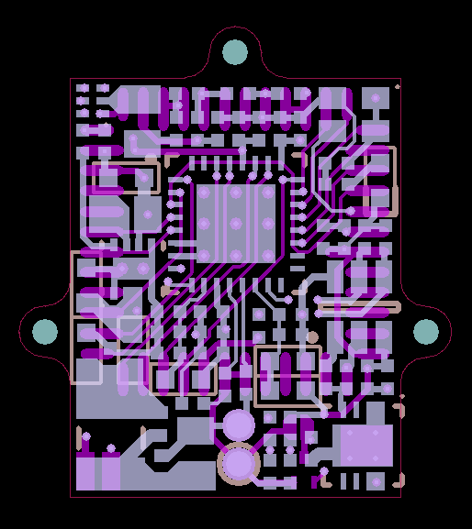**CMOS Imaging Sensor Circuit Board Fabrication Information**

* Number of layers: 4
  + Top Layer (GTL)
  + Mid Layer 1 (G1)
  + Mid Layer 2 (G2)
  + Bottom Layer (GBL)
* Substrate: 0.031” FR4 (No strict layer stack dimensions/properties)
* Board width: 17mm
* Board height: 18.5mm
* Board outline: Mechanical layer 1 (GM1)
* Minimum trace: 5mil
* Minimum clearance: 5mil
* Minimum via: 7mil
* Via in pad: Yes
* Filled vias: Yes (Non-conductive)
* Copper weight: 1oz
* Surface: ENIG
* Board shape: Custom
* Cutouts: None
* Solder mask color: Black
* Sinkscreen layers: Top and Bottom
* Sinkscreen color: White

|  |  |  |  |
| --- | --- | --- | --- |
| **Top** | **Mid 1** | **Mid 2** | **Bottom** |
|  |  |  |  |